2022 Critical Access Hospital  Certified Lactation Counselor (CLC)  Scholarship Application | 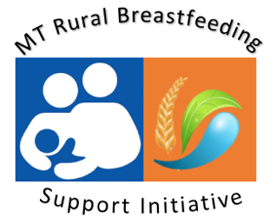
Overview
To increase breastfeeding support for rural Montana communities, the MT Nutrition & Physical Activity Program, in partnership with the Montana Hospital Association, is providing scholarships of $825 for CAH staff to complete the online Certified Lactation Counselor Training (CLC) by August,31, 2022. This 40-hour online course includes practical skills, theoretical foundations and competency verification. Application Deadline May 27th, 2022.
Applicant Information
Name: |  | Street Address:  (City & Postal Code)
Telephone: |  | EMAIL:
Critical Access Hospital Employer: |  | Supervisor Contact  (to verify employment).

This CLC scholarship helps cover registration, exam & textbook ($825) for a Montana Critical Access Hospital Requirements:
- Montana resident, employed in mother-baby care at a Montana Critical Access Hospital Community;
- Must complete the online training and examination by January 31st, 2022;
- Attending training will support applicant’s facility lactation program;
- Selected applicants will be required to register and pay for CLC – scholarship award will be sent to your facility or directly to applicant.
Please Respond
Please describe your current role at your facility & how completion of the online Certified Lactation Counselor Training will:
1) Support lactation work at your hospital & community ;
2) Support your professional goals in lactation support;
3) Also highlight specific challenges and barriers to breastfeeding support in your community.

Scoring is based on a thorough response to the three questions. Please return application to TMiller6@mt.gov by Friday, May 27th, 2022

