Critical Access Hospital  Train the Trainer – Breastfeeding Training Request | 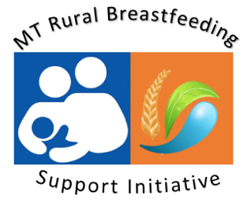
Overview
Rural Breastfeeding Support Initiative With the goal of increasing breastfeeding education support opportunities in rural MT communities, The MT Nutrition & Physical Activity Program (NAPA), with partnership from the Montana Hospital Association, will provide a free - 4 hour basic breastfeeding education training for healthcare staff of Critical Access Hospital communities. Please complete the following application to request a training at your facility.

Facility Information
Critical Access Hospital |  | Street Address:  (City & Postal Code)
Main CAH Contact: |  | Position
Phone |  | Email

Course Outline
- Breastfeeding Data & Trends - Lactation Physiology & Breastmilk Composition - Breastfeeding Benefits
- Support Techniques - Trouble Shooting Common Breastfeeding Challenges - Supporting the Bottle-Feeding Child - Including Family in Breastfeeding Support - Breastfeeding Resources - Next Steps in Lactation Support.

Learner will be able to:
1. Name several benefits to breastfeeding; | 2. Understand basic physiology of breastmilk production;
3. Know keys to get breastfeeding initiated successfully; | 4. Be familiar with basic breastfeeding positioning;
5. Be familiar with common breastfeeding challenges; | 6. Know where to locate breastfeeding support resources.

Requirements:
- Montana Critical Access Hospital;
- Conference room that holds up to 15 people;
- Projector & Screen (preferably with WIFI capability);
- Optional – lunch/snack option for participants.

Training Date Requests/ Please respond with a few different month options
Date 1: |  | Time
Date 2: |  | Time
Date 3: |  | Time

Please describe current breastfeeding support structure at your facility and any specific breastfeeding support gaps in knowledge that you would like addressed during the training (example: benefits and techniques of hand expression).
Please return completed training request to TMiller6@mt.gov

