Critical Access Hospital  Certified Lactation Counselor (CLC)  Scholarship Application | 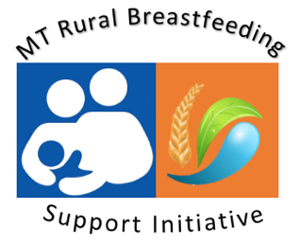
Overview
To increase breastfeeding support for rural Montana communities, the Montana Nutrition & Physical Activity Program (NAPA) in partnership with the Montana Hospital Association (MHA), is providing scholarships of $1000 for CAH staff to attend the Certified Lactation Counselor Training (CLC) in Hamilton, Montana May 4-8th, 2020. This 40-hour course includes practical skills, theoretical foundations and competency verification.

Applicant Information
Name: |  | Street Address:  (City & Postal Code)
Telephone: |  | EMAIL:
Critical Access Hospital Employer: |  | Supervisor Contact  (to verify employment).

This CLC scholarship helps cover registration, lodging, travel ($1000) for a Montana Critical Access Hospital L&D direct care staff to attend the Certified Lactation Counselor Training Hamilton, MT May 4th-8th, 2020. More CLC Training Information found Here.
Requirements:
- Montana resident;
- Employed in direct labor & delivery care at a Montana Critical Access Hospital;
- Attending training will support applicant’s facility lactation program;
- Selected applicants will be required to register and pay for CLC – scholarship award will be sent to your facility or directly to applicant.

Please Respond

Please describe your current role at your facility & how your attendance at the Certified Lactation Counselor Training will: 1) Support lactation work at your hospital, 2) support your professional goals in lactation support & 3) address any additional barriers to attending lactation trainings. Scoring is based on a thorough response to the above questions.
Please return completed application to TMiller6@mt.gov by Friday, January 17, 2020

