Critical Access Hospital  HOST A CERTIFED LACTAION COUSELOR (CLC) TRAINING at YOUR CAH | 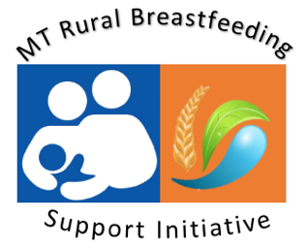

Overview

Rural Breastfeeding Support Initiative - With the goal of increasing access to certified lactation counselors in Montana’s rural communities, the MT Nutrition & Physical Activity Program (NAPA), in partnership with the Montana Hospital Association, will partner with a Montana Critical Access Hospital to host a Certified Lactation Counselor Training at their CAH facility.

Facility Information
Critical Access Hospital |  | Street Address:  (City & Postal Code)
Main CAH Contact: |  | Position
Phone |  | Email

Outline
The NAPA program will work directly with CLC Training providers (Healthy Children’s Center for Breastfeeding) and selected Critical Access Hospital facility to provide the 40-hour Certified Lactation Counselor Training at their CAH site. The selected hospital will receive 2-3 free registrations for their staff to attend the training. The MT NAPA program will work with partners to organize and promote training across the state.

Host Site Requirements:
- Montana Critical Access Hospital;
- Provide free use of conference room (5 days) for 30+ attendees with table set-up (M-F 8AM-5PM);
- Projector, screen, microphone (preferably with WIFI capability).

Other Considerations
- NAPA will choose 1 different Critical Access Hospital site to host a CLC Trainings site each year for 5 years.
- Preference given to those host sites that can help garner at least 20 registrations (the minimum required to host a training.
- To increase attendance, CLC training to be held during the non-winter months.
- Please note we are selecting CLC host sites for 2021-2024.

Questions:
Does facility have conference room? If so, how many seats?
Best months to host a CLC training at your facility?

Please describe current breastfeeding support structure and why you are interested in hosting a CLC at your CAH.
Please return completed request to host a CLC training to TMiller6@mt.gov

